Family Participation Fees:
Family Participation Fees are payments made by families for Early Intervention (EI) services that are subject to fees. Not all EI services are subject to fees. Direct services, like Physical Therapy, Developmental Therapy, or Speech Therapy are subject to fees. Other services such as Service Coordination, Evaluations, Assessments and Individualized Family Service Plan (IFSP) Development are not subject to fees. You can find a detailed list of services subject to fees in the EI Cornerstone Family Fee Report you receive from your Service Coordinator.

Requirement for Households Paying Family Participation Fees:
The Early Intervention Program requires that able families help pay for their child and family’s EI services. Families who are receiving All Kids (Excluding Premium Level 2 – 8), WIC, or whose income is at or below 185% of the federal poverty level are not required to pay a fee.

Comparison of Free Services Provided by the School District:
The Free Appropriate Public Education (FAPE) requirement does not apply to EI. The Individuals with Disabilities Education Act (IDEA) says that EI services must be “provided at no cost except where Federal or State law provides for a system of payments by families, including a schedule of sliding fees,” (Section 632 (B)). 325 ILCS 20/ Early Intervention Services System Act is the state statute that allows a sliding scale payment system.

Calculation of Amount of Family Participation Fees:
The fee assessment first calculates how much your family is able to pay over the course of one year and then breaks that down into a more convenient monthly amount called the Level Payment Amount. Fees are redetermined annually. Fees are calculated using your family size (for tax reporting purposes), your annual gross income (for tax reporting purposes) and considers any excessive Out-of-Pocket medical/disaster expenses. You can estimate your fee amount using the following table. When families choose not to disclose their income to EI, the family agrees to accept the highest family monthly installment while active in EI. This table is updated annually based on the Federal Poverty Levels (FPL).

FY 2021 FEE CALCULATION (Effective July 1, 2020)
Find column where family size and gross income meet to determine child’s monthly fee installment:
Family Size | $0 / Month Installment | $10 / Month  Installment |  | $20 / Month  Installment |  | $30 / Month  Installment |  | $50 / Month  Installment |  | $70 / Month  Installment |  | $100 / Month  Installment |  | $150 / Month  Installment |  | $200 / Month  Installment
 | 0-185%  FPL | > 185-200% FPL |  | > 200-250% FPL |  | > 250-300% FPL |  | > 300-350% FPL |  | > 350-400% FPL |  | > 400-500% FPL |  | > 500-600% FPL |  | > 600%  FPL
2 | $0 – 31,894 | $31,895 –  34,480 |  | $34,481 – 43,100 |  | $43,101 –  51,720 |  | $51,721 –  60,340 |  | $60,341 –  68,960 |  | $68,961 –  86,200 |  | $86,201 –  103,440 |  | Above  $103,440
3 | $0 – 40,182 | $40,183 –  43,440 |  | $43,441 – 54,300 |  | $54,301 –  65,160 |  | $65,161 –  76,020 |  | $76,021 –  86,880 |  | $86,881 –  108,600 |  | $108,601 –  130,320 |  | Above  $130,320
4 | $0 – 48,470 | $48,471 –  52,400 |  | $52,401 – 65,500 |  | $65,501 –  78,600 |  | $78,601 –  91,700 |  | $91,701 –  104,800 |  | $104,801 –  131,000 |  | $131,001 –  157,200 |  | Above  $157,200
5 | $0 –  56,758 | $56,759 –  61,360 |  | $61,361 – 76,700 |  | $76,701 –  92,040 |  | $92,041 –  107,380 |  | $107,381 –  122,720 |  | $122,721 –  153,400 |  | $153,401 –  184,080 |  | Above  $184,080
6 | $0 – 65,046 | $65,047 –  70,320 |  | $70,321 – 87,900 |  | $87,901 –  105,480 |  | $105,481 –  123,060 |  | $123,061 –  140,640 |  | $140,641 –  175,800 |  | $175,801 –  210,960 |  | Above  $210,960
7 | $0 – 73,334 | $73,335 –  79,280 |  | $79,281 – 99,100 |  | $99,101 – 118,920 |  | $118,921 –  138,740 |  | $138,741 –  158,560 |  | $158,561 –  198,200 |  | $198,201 –  237,840 |  | Above  $237,840
8 | $0 – 81,622 | $81,623 –  88,240 |  | $88,241 – 110,300 |  | $110,301 – 132,360 |  | $132,361 –  154,420 |  | $154,421 –  176,480 |  | $176,481 –  220,600 |  | $220,601 –  264,720 |  | Above  $264,720
For family sizes above 8, add the following to above income ranges for each additional family member:
1 | $0 –  8,288 | $8,289 –  8,960 | $8,961– 11,200 |  | $11,201 – 13,440 |  | $13,441 – 15,680 |  | $15,681– 17,920 |  | $17,921 – 22,400 |  | $22,441 – 26,880 |  | Above $26,880
** Based on FFY 2020 Federal Poverty Level Guidelines. This table is updated annually. **

The Level Monthly Payment Amount begins when your family’s services subject to fees are authorized to begin and ending when your family’s IFSP ends. This period, called the Family Fee Effective Period, is listed on your EI Cornerstone Family Fee Report.

Your maximum Out-of-Pocket Family Fee (listed on your EI Cornerstone Family Fee Report) is calculated based on your Family Fee Effective Period. The monthly level payment amount is sent each month to any family who qualifies for a Family Fee. The monthly level payment amount accrues the first month that one or more of your Authorizations for services subject to fees begins on or before the 15th of the month. You will receive a bill (invoice) for each month your family is active in EI through the month your IFSP ends on or after the 16th of the month.

Required Financial Documentation used to Determine the Family Participation Fee Amount:
You will be asked to provide your family’s most recent Federal Income Tax form(s) in order to document gross annual income. If a recent Federal Income Tax form does not accurately reflect your annual gross income or is not available, two recent consecutive check stubs may be used.

If your child is covered by Medicaid/All Kids or WIC, you will be asked to provide a copy of his/her current Medicaid/Kid Care Recipient Card or WIC Identification Card. In addition, you will be asked to provide a verbal indication of your annual gross income.

Family Participation Fee Household Calculation:
One Family Fee is assessed per family, even if more than one child is enrolled in the EI Program. Neither your maximum-Out-of-Pocket nor your monthly level payments will increase due to multiple children entering/receiving EI at the same time because the Family Participation Fee is based strictly on household size and income when you entered, not how many children participate in the program.

Affording Family Participation Fees during Changes or Extenuating Circumstances:
The Illinois EI definition of ability to pay is comparing household size and taxable reported income to the Federal Poverty Level on a sliding scale and considers Out-of-Pocket medical/disaster expenses. A family meets the definition of ability to pay if the family falls within the scale and does not have proven Out-of-Pocket medical (allowable as IRS deductions) or disaster (fire, flood or act of nature) expenses in excess of 15% of the reported income. If a family does not meet the state’s definition of “ability to pay”, the family must be provided all EI IFSP approved and consented services at no cost without delay.

You may request that your family fee be re-assessed at any time if your income or family size changes. You may also request exemption from fees if current medical expenses or other expenses due to natural disaster such as fire, flood or tornado as defined above exceed 15% of your gross annual income.

Changes to your family’s fee may only be applied prospectively. This means that the portion of your fee that has accrued up to the time you request a re-assessment or exemption cannot be changed in the system. Therefore, it is important that you notify your Service Coordinator as quickly as possible when a re-assessment or exemption is needed.

You must request a re-assessment or exemption through your Service Coordinator. You must follow the policies and procedures of requesting a Family Fee Exemption. This includes steps such as signing an Exemption Request form and providing documentation of the expenses. If approved, the Exemption begins when the Department of Human Services, Bureau of EI receives the signed form from the Service Coordinator.
Family Fee Invoices
If your family has been assessed a fee, you will receive a monthly invoice, like the one below, from the EI Central Billing Office (CBO).

Family Fee Invoices are mailed during the first week of every month. Payments are due to the State on the date shown on the Invoice. Families with more than one child in EI should receive one Family Fee Invoice. If your family has more than one child in EI and is receiving more than one invoice, contact your Service Coordinator and notify him/her of the problem.

SAMPLE INVOICE
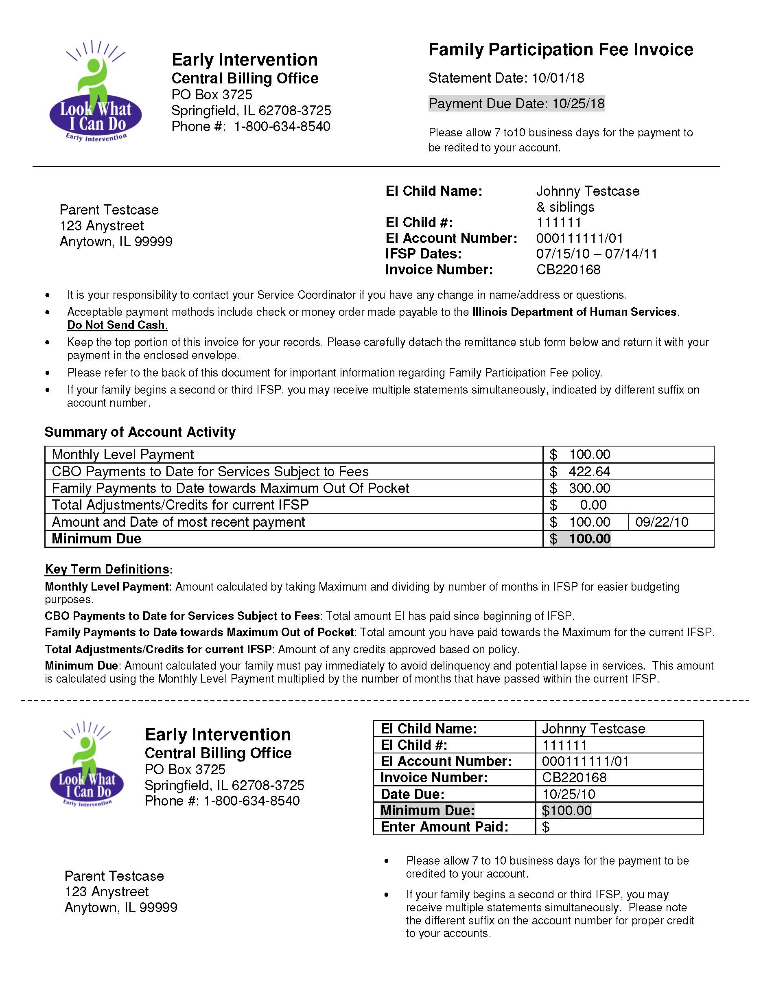

Understanding Your Family Fee Invoice
PO Box 3725
Springfield, IL 62708-3725
800/634-8540
These definitions may help you understand your Family Fee Invoice. You may refer to the Sample Family Fee Invoice (see page 3) to see how these items are arranged on the Invoice.
- Monthly Level Payment: The Maximum Out-of-Pocket (from your Cornerstone Family Fee Report) broken down into monthly installment amounts. This level payment assists families in budgeting their EI expenses.
- EI CBO Payments to Date for Services Subject to Fees: This is the total amount accumulated from the beginning of the affected IFSP. It is strictly an amount to determine if any Minimum Due is owed by your family. You will accrue a monthly level payment each month but only owe a Minimum Due if CBO pays any direct services for your child(ren)/family.
- Family Payments to Date towards Maximum Out-of-Pocket: This is the total amount accumulated from the beginning of the affected IFSP that your family has sent to EI.
- Total Adjustments/Credits for current IFSP: This is any amount EI determines your family was incorrectly charged. This may be credits issued because your family fee maximum Out-of-Pocket was decreased due to changes of household size/income or credits issued because your services ended prior to the end of the IFSP but the case was not correctly closed in the system.
- Amount and Date of most recent payment: The amount and date of when EI received your most recent payment.
- Minimum Payment: This amount is calculated by taking the amount paid by EI during the IFSP period for the family’s services subject to fees, minus the family payments to date based on the monthly level payment amount, whichever is less. NOTE: You will not be required to pay more in fees than the State pays for your family’s services subject to fees.
NOTE: Please review the reverse side of your invoice for additional information.

Payment Options
Determining Monthly Payment Amounts:
You will be required to pay at least the Minimum Payment amount listed on your family’s fee invoice. However, if the amount EI paid for services are less than your Current IFSP Maximum Out-of-Pocket, you have two payment options. You may choose to either:
- Pay the Monthly Level Payment amount as indicated (this is the recommended payment option because it is the only way to make sure that your minimum due is never higher than the level payment amount) or
- Pay the Minimum Payment amount as indicated on your fee invoice.
The Minimum Payment amount is based on how much the State has paid your EI Provider(s) for services subject to fees. This amount may vary by month because EI Providers have up to 90-calendar days from the date of service or last written correspondence with the insurance company to bill for EI services. Corrected or resubmitted claims that were originally denied or not billed in the correct amount must be received within 60 days of the insurance correspondence date, if applicable. This means that the State may not pay anything for your family’s services subject to fees for several months.

Later, when your EI Provider starts submitting claims to EI, EI will begin making payments which does affect your Family Fee.

If you do not pay the Monthly Level Payment amount, and instead wait to pay until EI incurs some expense on behalf of your family, you may be required to pay an amount much higher than the level payment plan would have required. For this reason, families are usually encouraged to select the level payment plan by paying their Monthly Level Payment every month.
Utilizing private health insurance to reduce costs to the EI program:
Only EI services subject to fees that are paid for by the State are used to calculate the Minimum Payment amount. This means that you will not be charged for EI services subject to fees that are paid for by your private insurance.

Delinquency and Reconciliation
Skipping Family Participation Fee Payments:
If a Minimum Payment amount becomes equal to three or more Monthly Level Payment amounts overdue, EI services subject to fees, including Assistive Technology devices, will be discontinued with written prior notice to you. Services not subject to fees may continue. As indicated to you in the booklet you received titled State of Illinois, Infant/Toddler & Family Rights under IDEA for the Early Intervention System your family has the right to appeal this decision. If your family does appeal by following the provisions within the Family Rights booklet, certain services may continue during the appeal process.

Overpaying Family Participation Fees:
Nine months after the IFSP has ended (or earlier if possible), the EI Program will verify that you have not paid more in fees than the EI Program has paid for your services subject to fees. This is called reconciliation or reconciling your account. If you have overpaid and one or more children remain in the EI Program, your current account will be credited any amount overpaid in previous accounts. If you do not have any other children in the EI Program, your overpayment will be refunded. After the 9 months has passed, it is your responsibility to contact the CBO at 800/634-8540 and provide the current address and SSN of the FRA or other parent/guardian living in the household in order to receive your refund. The check will be issued by the Illinois Office of Comptroller. To receive your refund, you must contact the CBO at 800/634-8540 and be prepared to share your child’s EI # from the invoice as well as the Social Security Number of the Financially Responsible Adult listed on the invoice. Once your family has no children in EI for 12 months, the CBO will cease sending invoices showing any balance owed to you however, you may contact the CBO any time after the 12 months to request the refund. EI will also not be able to refund a payment under $5 per rules set by the Office of the Comptroller.

EI will not automatically refund an overpayment and notices of potential refund will only be sent for one year after your child exits the program. There is a potential to receive the refund earlier if all criteria is met. If applicable, you may request an early refund by contacting your Service Coordinator. The following criteria must be met EI must obtain written documentation from your EI Provider(s) verifying that they have been paid in full and will not be billing the State for any other authorized EI services. There is not a requirement of the EI Provider to comply with such a request, so the policy of the reconciliation process is the primary way of determining any refund. No refund will be issued without the SSN of the FRA/Parent/Guardian.
Understanding Your Rights
Disagreement with Family Participation Fee Calculations:
If you do not agree with the family participation fee that has been calculated for your family, you have the right to dispute the assessment. The booklet entitled, State of Illinois: Infant/Toddler and Family Rights under IDEA for the Early Intervention System has information about filing a complaint. You should notify your Service Coordinator of any errors on the calculation no more than 30-calendar days after you receive your family’s EI Family Fee Report that tells you your fee amount to have it corrected prospectively in the system and a new report printed and sent to you.

More Information
If you have questions about your fee statement, you may contact the CBO at 800/634-8540.

If your income and/or family size has changed and you wish to request a re-assessment of your family fee or you are experiencing excessive medical or disaster expenses and wish to request a fee exemption, you must contact your Service Coordinator immediately. As explained on the EI Cornerstone Family Fee Report, changes are only made on future monthly installments. The system has no way of making changes for past months.

If you would like more information about the EI Program, you may visit the IDHS EI website at www.dhs.state.il.us/ei/.

